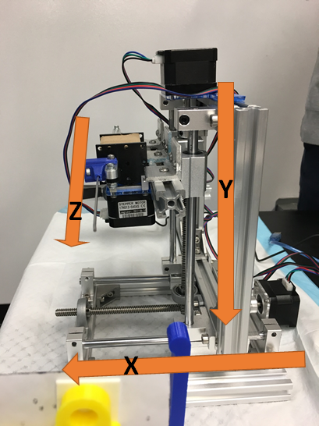

Figure 1. (please change this pic to the new one.)

Concept and Realization of the System Design

After camera calibration, we get the depth information between camera and fiducials frame as well as all intrinsic parameters, which can transfer pixel values to real world dimensions. In our project, we need to know the relative position from needle tip to the 3 target points, respectively. Consider this to be an eye-to-hand calibration problem. We can build a transformation chain from needle tip to the targets in reverse direction, which means going through end effector, robot base, camera, fiducials, targets. The equation below can be used to represent our design concept.

……………………………………………….………………..…….(1)

and represent the transformation matrices from robot base frame to camera frame and from camera frame to fiducial frame respectively. is the end effector (needle tip in our design) position in the robot base frame. are the 3 targets position in the fiducial frame. We select the position of the first motor shaft as the origin of the robot base coordinate frame, the principal point of the camera as the origin of the camera coordinate frame, the intersection points of the z axis of the camera frame and the fiducial plane as the origin of the fiducial coordinate frame. The kinematic chain can be described used the following graph.

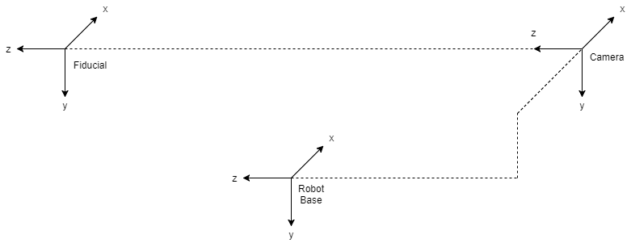

After measurement,

;

;

;

;

;

; ; .

x, y, z are motor rotation distances, Z is the distance between xy plane of the camera frame and xy plane of the fiducial frame. By doing tests to reach 3 targets, we get the constant offset from the system, which are -7.5, -28, -13 mm along x, y, z axis respectively. Combine everything we get above and put them into the equation (1), we can get the expected movement of 3 motors in mm unit. To transfer the unit to steps of the step motors:

………………………………(2)

………………………….……(3)

………………………….....(4)

pitchDiameter equals 12.7 mm, stepsPerRevolution equals 200, pitchLeadscrew equals 2 mm. We build the full system completely now.

When dealing with the operation tests, we can take a picture of the fiducial markers, run the calibration code to detect all 3 fiducials. Then we use the first fiducial as the reference, calculate the position of it, and yield 3 targets’ position based on it. Finally, we get the required motor steps from equation 1 and input to the arduino, let the needle tip to pierce through the targets.

Image Processing

After using the webcam to take a snapshot, we then utilize image processing methods to extract the fiducial marker from the taken image. We first transformed the image into HSV (Hue, Saturation, Value) color space. Then we set thresholds for each color space in order to retrieve fiducial color, removing other undesired colors(Figure 2).

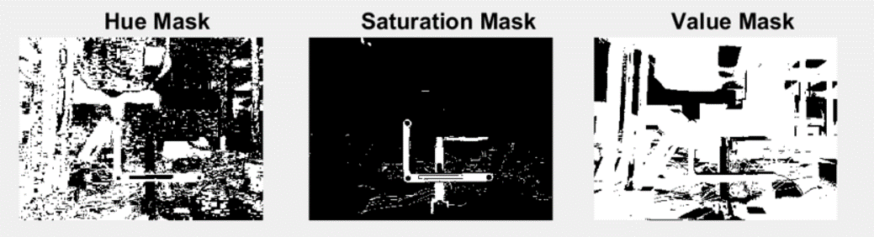

Figure 2. The results of transforming image into HSV color space.

After applying the threshold mask, we then combined Hue and Saturation image. In addition, we also applied median filter to remove the noise within the image(Figure 3).

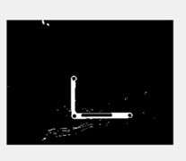

Figure 3. Image processing result after applying threshold mask and median filter.

Lastly, we found areas which its eccentricity is greater than 0.1 but less than 0.5. Moreover, the areas contain more than 15 pixels(Figure 4). By doing so, the position of three fiducial markers can then be identified from the image.

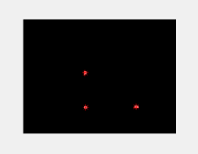

Figure 4. Image processing result after extracting circular areas.

Although we got three fiducial markers position in the image, we still need to calculate the actual position related to the optical axis. From the camera calibration assignment, we got an intrinsic matrix which include both axis’ focal length and offset. The depth information(Z) of the fiducial frame can also be measured through camera calibration procedures.

We then can calculate the position(mm) of the three fiducial markers.

…………………………………………………………………...…….(5)

……………………………………………………………………….(6)

Where and are the position in millimeter, and and are the position in pixel.

Experimental results

Since our design is an open loop system, we can’t get numeric feedback of how much error is from the needle tip to the targets’ center. We can only see from the following pictures that the needle tip can pierce through target holes in all experimental cases, even minute error exists.

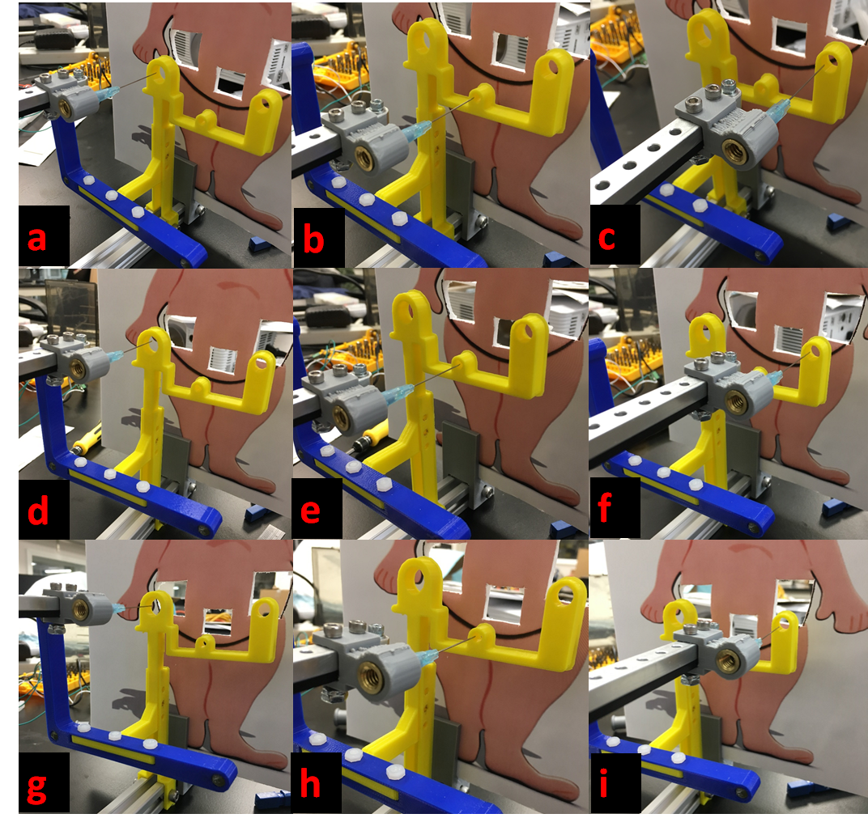

Figure 5. Results of the experiment.

From the result (Figure 5), figures a, b, and c were taken while fiducial frame was fixed at the calibration plane. Figures d, e, and f were taken while we moved fiducial frame -5 mm along x-axis and +10 mm along y-axis. Figures g, h, and i were taken while we moved the fiducial frame -15 mm along z-axis compared to the position in the picture d, e, and f.